Contemporary View 3 of 4

Thaddeus Stevens Gravesite & Memorial – Concord-Shreiner Cemetery, City of Lancaster, PA
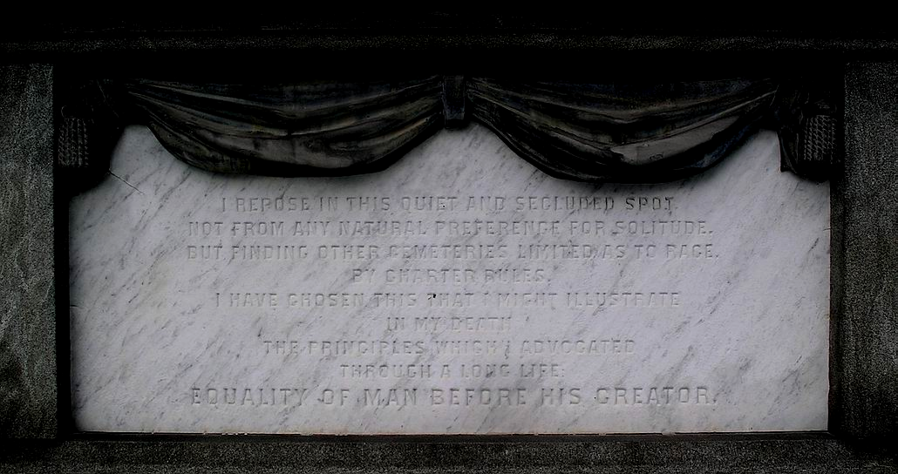
Detail- Epitaph: Stevens Grave Site/Memorial – South-facing elevation

Photo by Randolph J. Harris
January 4, 2006
Neighborhood Preservation/Community Development, Mount Joy, Pennsylvania 17552
717-808-2941 harris233@earthlink.net
Prepared for an application of the Grave Site/Memorial of Congressman Thaddeus Stevens at Concord-Shreiner Cemetery, Lancaster, to the National Park Service Underground Railroad Network to Freedom Program.

