Contemporary View 4 of 4

Thaddeus Stevens Gravesite & Memorial – Concord-Shreiner Cemetery, City of Lancaster, PA
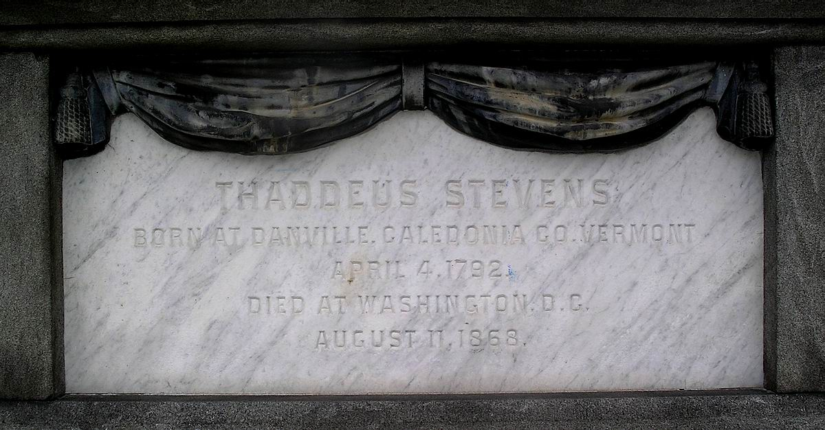
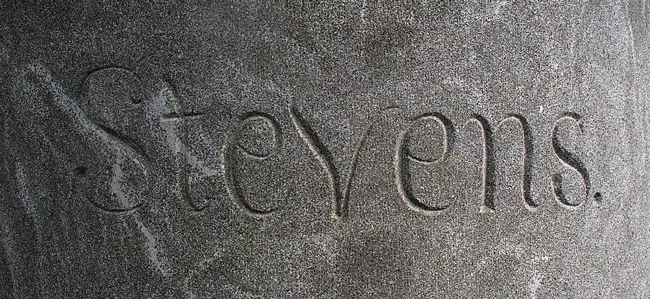
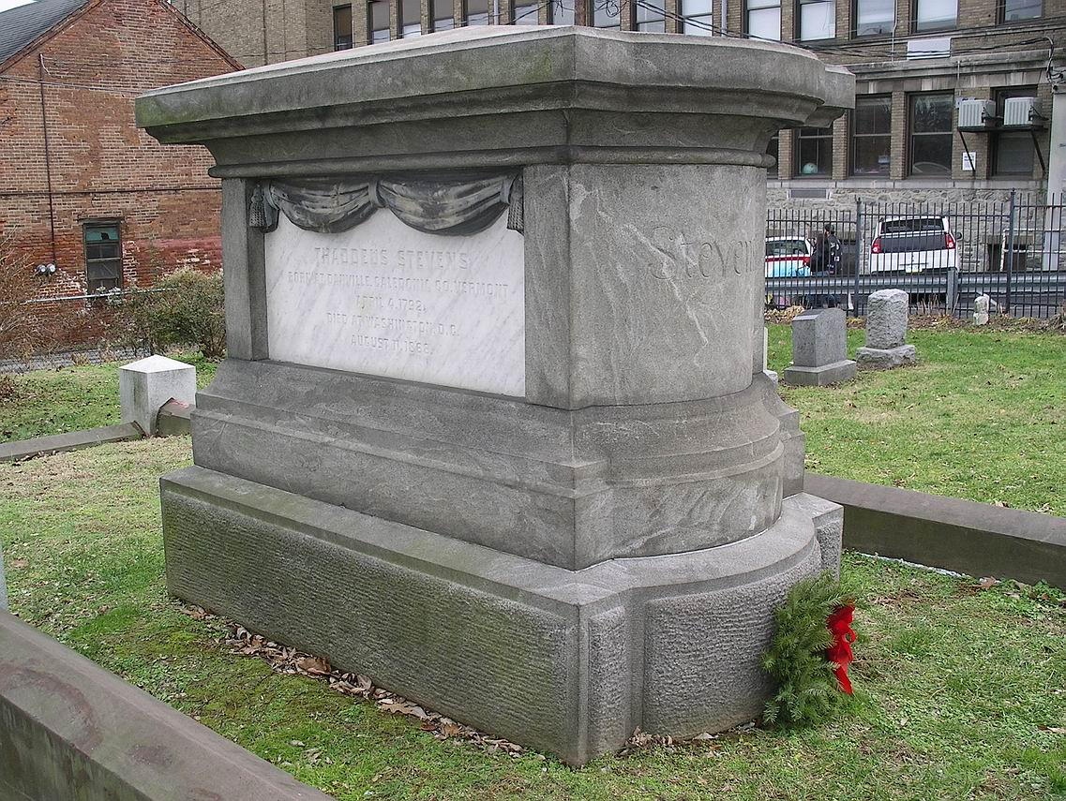
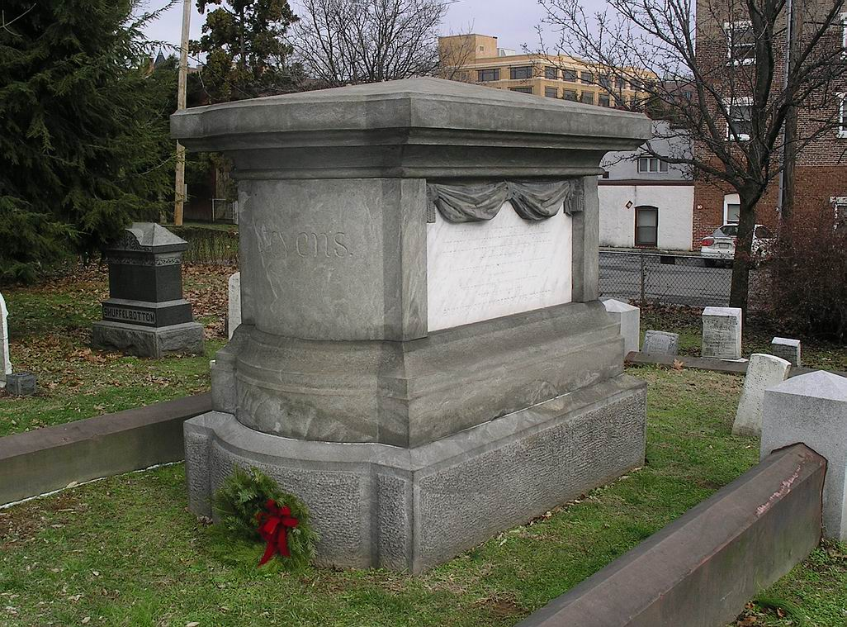
Top left: North Elevation – Stevens biographical information. Top right: West Elevation. Bottom left: West and South Elevations, Bottom right: North and West Elevations.

Photo by Randolph J. Harris January 4, 2006
Neighborhood Preservation/Community Development, Mount Joy, Pennsylvania 17552 * 717-808-2941 harris233@earthlink.net
Prepared for an application of the Grave Site/Memorial of Congressman Thaddeus Stevens at Concord-Shreiner Cemetery, Lancaster, to the National Park Service Underground Railroad Network to Freedom Program.

