In memory and tribute to

The Goodwin Family

From

Ruby N. Atwell
Steelton, Pennsylvania



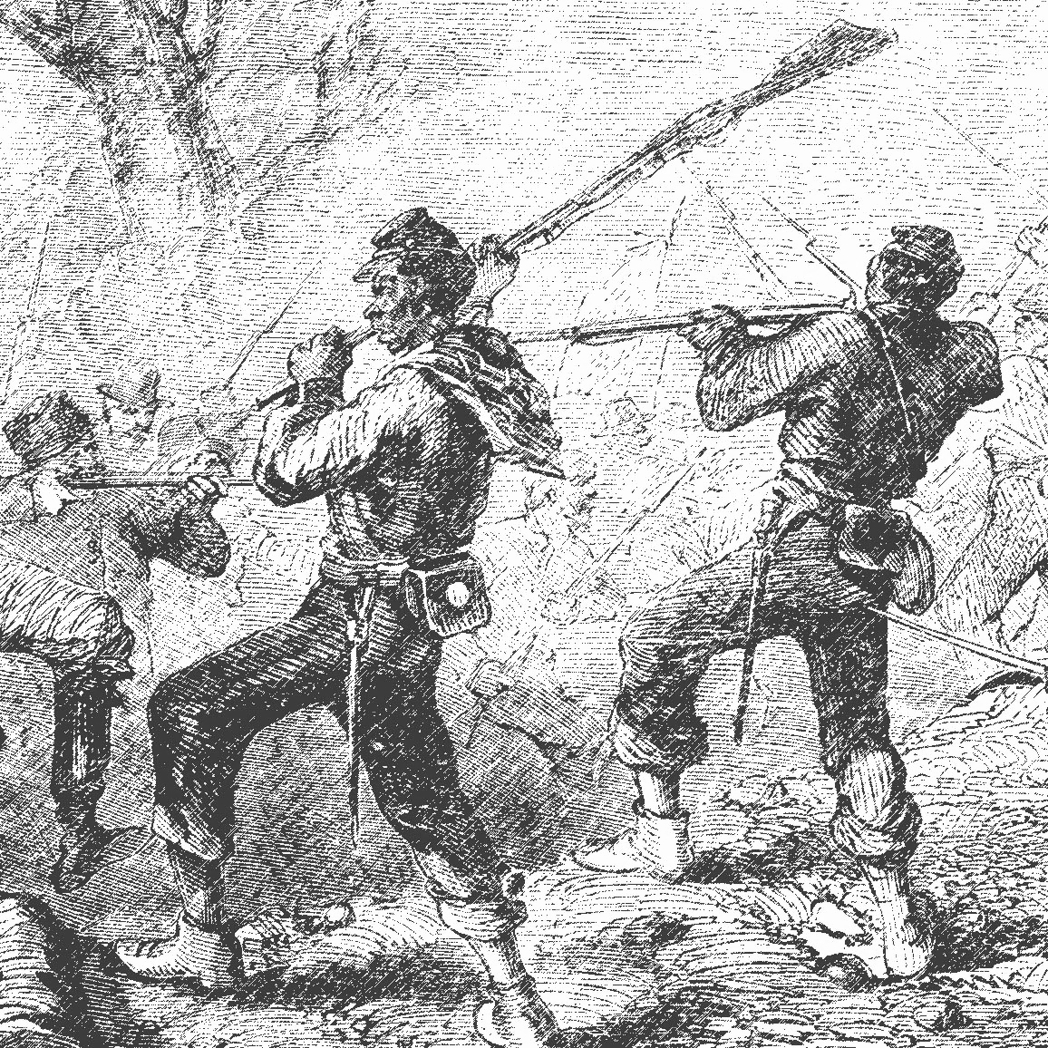
Friends of Midland, P.O. Box 7442, Steelton, PA 17113-0442; (717) 939-0242
Officers and Board members:

President Barbara Barksdale
Vice president Sharon Harris
Secretary Zane Phoenix
Treasurer Clayton Carelock
Assistant Treasurer Lonnie Dodd
Board Sherla Brooks
Calobe Jackson Jr.
Dr. Dorothy King
George F. Nagle

right: Detail from “Battle of Milliken’s Bend” a significant action in the Vicksburg Campaign, June 7, 1863, in which African American troops engaged Confederate troops in hand to hand combat.

