

America the Beautiful

Katherine Lee Bates

O beautiful for spacious skies,
For amber waves of grain,
For purple mountain majesties
Above the fruited plain!

America! America!
God shed his grace on thee
And crown thy good with brotherhood
From sea to shining sea!

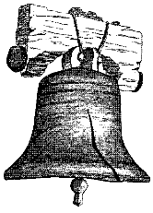

Lift Every Voice and Sing

James Weldon Johnson
1871-1938

Lift ev’ry voice and sing
Till Earth and heaven ring,
Ring with the harmonies of Liberty;
Let our rejoicing rise
High as the list’ning skies
Let is resound loud as the rolling sea.

Sing a song full of the faith that the dark past has taught us,
Sign a song full of the hope that the present has brought us;
Facing the rising sun of our new day begun,
Let us march on till victory is won.



