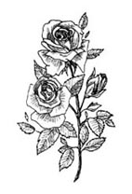

In honor and tribute to

Clarence Geary, M.D.
Marshal & Amanda Adams
Sheridan & Mary Crummy
Maude Vass
Robert Geary

And the Proctor and Geary Families

Courtesy of Norman Proctor

The Friends of Midland express sincere thanks to. . .

⬄ The United States Colored Troops reenactors, for the many years of support, travel, friendship and keeping history alive.

⬄ The Buffalo Soldiers for your support, travel, friendship and role in keeping history alive, and in particular in memory of Charles Young, uncle to Barbara Barksdale.

⬄ Harrisburg East Rotary for the gift of the flagpole and for your support of our efforts.

⬄ County of Dauphin for helping us get the work done.

⬄ Swatara Township for your never-ending support through the years.

⬄ Borough of Steelton for your continued support also.

