African American Participation in the Korean War
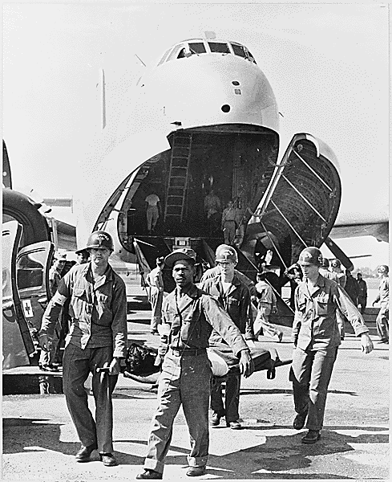
Historic Photographs from the National Archives

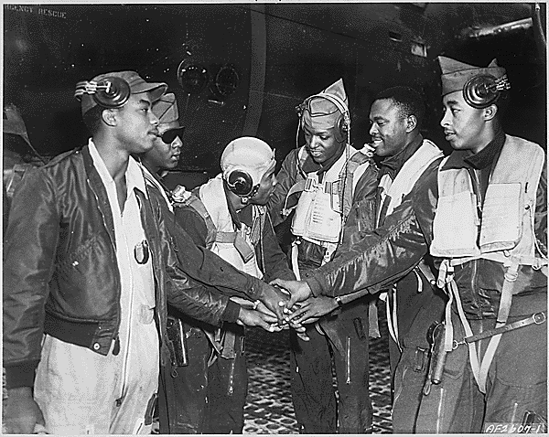
❐
FIFTH AIR FORCE, KOREA--Six gunners join hands as a part of 17th Bomb Wing night interdiction teams in Korea, ca. 09/1952

On patrol in Japanese territory off the Numa-Numa Trail in the South . May 1, 19
Army medics carry wounded UN personnel to  waiting ambulances, after the patients' arrival at this Tokyo base in the U.S. Air Force C-124 in the background.
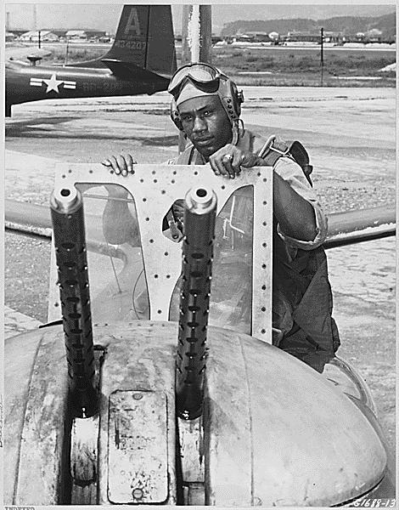
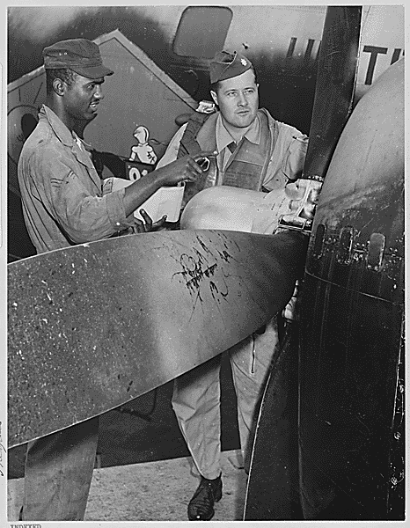
" Lt. Col. Marle M. Jones, Riverside, Calif., new commanding officer of the 91st Strategic Reconnaissance Squadron gets a final O.K. from the crew chief of his B-29 "Superfort" photo plane before leaving on a mission into Communist Korea, ca. 09/1952” 

" T/Sgt. Charles W. Ledbetter is shown as he returned shortly after daybreak from a pre-dawn strike against Communist troop and supply lines. Assigned to the 3rd Bomb Wing, Sgt. Ledbetter has flown 25 night missions as engineer-gunner in Fifth Air Force B-26 light bombers. ca. 07/1951”
❑

