Friends of Midland – Reflections

1993
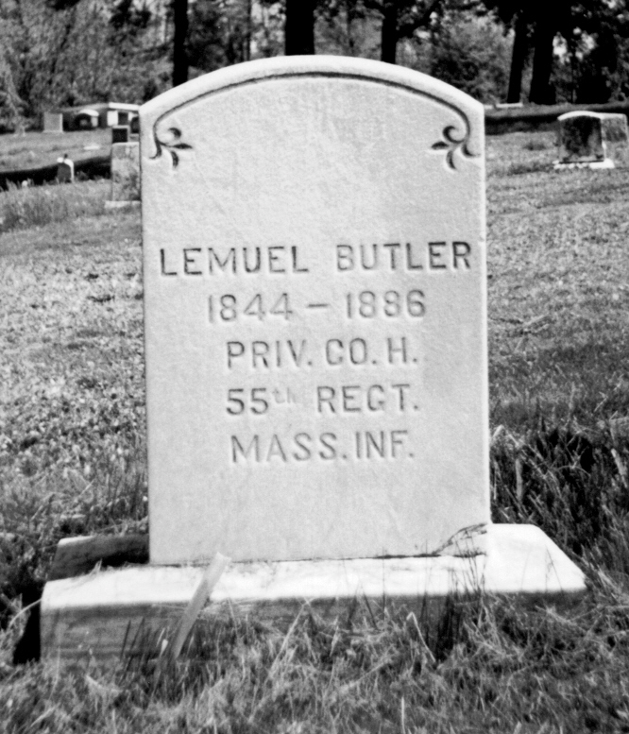
The Friends of Midland was formed by Barbara Barksdale as a means to raise awareness about Midland Cemetery, and was incorporated on June 17, 1993 as a Nonprofit Organization. The first year, the Pennsylvania Conservation Corps aided in the removal of three acres of trees, weeds and brush from the site, enabling the Friends to hold its very first Memorial Day Service in the reclaimed cemetery that year. We also held a pledge banquet at First Baptist Church in Steelton and welcomed the help of Dauphin County Prison inmates for the first time in cleaning the site. The success of this first clean up led to the expansion of the service program for Dauphin County, utilizing DCP inmates. Our thanks go to Warden DeRose for his continuing faith in this project.

Research Highlights: The Friends of Midland proved the existence of African American veterans’ burial sites at the cemetery.

1994
The Friends of Midland celebrated our first anniversary by continuing with the Memorial Day service, the pledge banquet at First Baptist Church and the partnership with Dauphin County that allowed the use of inmates to assist with regular clean up operations.

1995
Representative Ronald Buxton helped secure funds to construct a shed for tool and equipment storage. By this time, the Memorial Day service had become a tradition that would continue to the present day. The history at Midland also became part of the curriculum at Elizabethtown College as Barbara Barksdale shared her collected stories and research with students there.

1996
Electrical service was installed, providing power to the storage shed for convenience and security. Friends of Midland board members began working with Dickinson College students this year, who collected oral history stories and documentation, and put Midland on the World Wide Web for the first time. This was the first year that we invited the Buffalo Soldier reenactors for an encampment and parade in Steelton.

1997
Water service was added this year, to aid in the regular cemetery clean up activities. In addition to our regular force of Dauphin County Prison inmates, volunteers from the Scotland School for Veteran’s Children assisted with the clean up and learned Midland history. This year marked the first Memorial Day Wreath Laying Ceremony with the U.S. Colored Troops reenactors.

1998
Friends of Midland board members participate in the unveiling of the United States Colored Troops Memorial in Washington DC, representing the U.S.C.T. veterans that are buried in Midland. Governor Tom Ridge proclaimed May 23 as “U.S.C.T. Day in Pennsylvania” for the Friends of Midland.

1999
The Historical Memorial Marker was erected at Midland, with a proclamation by Swatara Township officials, citing Midland as the first officially recognized historic site in Swatara Township.

2000
The Friends of Midland continued gathering oral history and researching local history, in conjunction with Dickinson College students. More headstones were unearthed by DCP inmates on a regular clean up activity. Neighbors donated a bench on which visitors rest, and the Borough of Steelton donated a riding lawnmower.

2001
The Pennsylvania Historical and Museum Commission recognizes the valuable work being performed by the Friends of Midland by presenting the organization with a Preservation Award. At the annual Memorial Day service, we honored American Legion Post 479, an African American post with strong ties into the local community. The Friends of Midland also received the Liberty Bell Award from the Young Lawyers Association, in the presence of Ed Rendell and Pennsylvania State Attorney General Mike Fisher.

2002
The Friends of Midland established an official website at the Afrolumens Project, www.afrolumens.org. Regular Memorial Day services continued, along with restoration and preservation work with the aid of DCP inmates and other volunteers.

2003
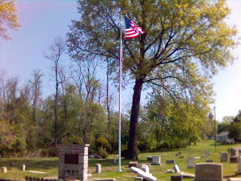
The Friends of Midland celebrated ten years of service with a gala Memorial Day event and parade featuring U.S.C.T. reenactors, the Dauphin County Prison Color Guard, Brownie Troop 815, Temple Guard Drill Team, VisionQuest Buffalo Soldiers, Confederate soldier reenactors, civilian reenactors, Milton Hershey School students, Himyar Temple #17 and local government representatives.

2004
We continued stronger and more dedicated than ever to the mission of educating the community about the cultural, historical and community treasures that make up Midland Cemetery. Damage from summer storms that knocked down several trees was cleaned up with the help of people from the local community.

2005
With the generous help of Harrisburg East Rotary and the Borough of Steelton, we were finally able to have installed a magnificent flagpole, complete with lighting. We also received the donations of additional lawn maintenance equipment.

Thanks to our members, past Board Members and supporters

