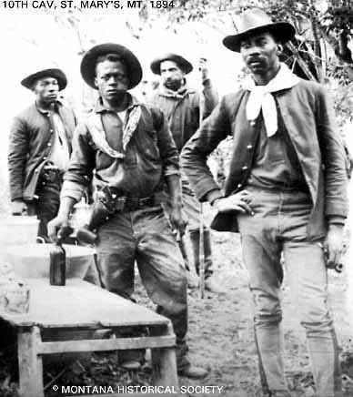
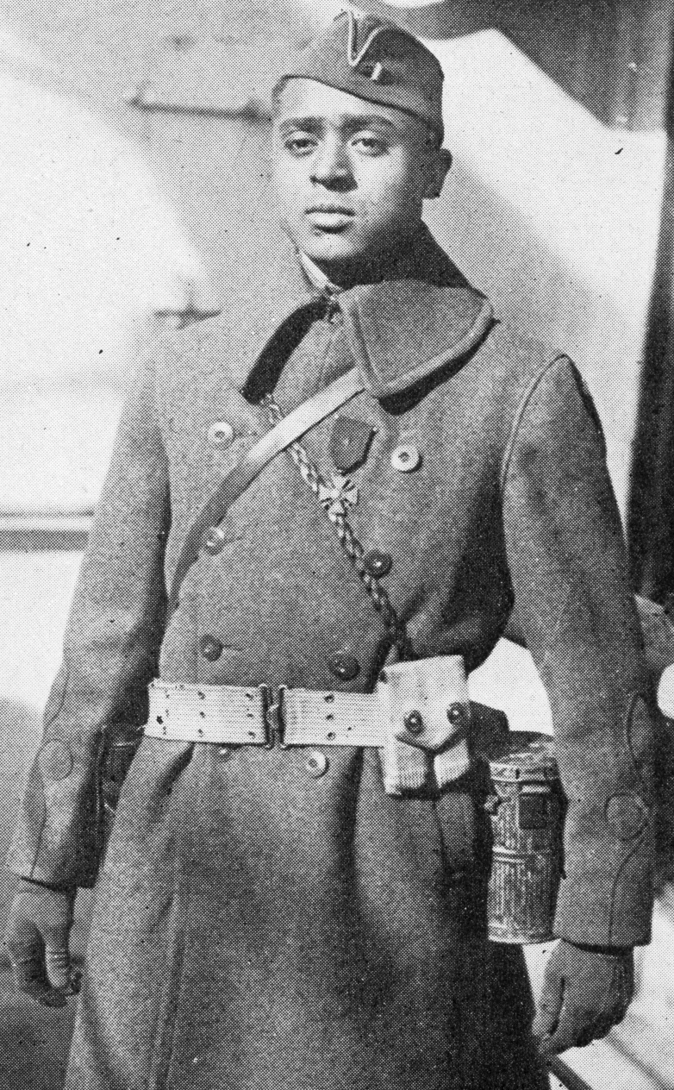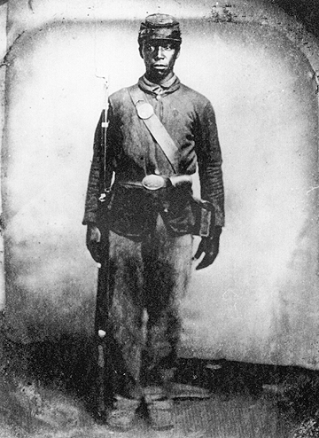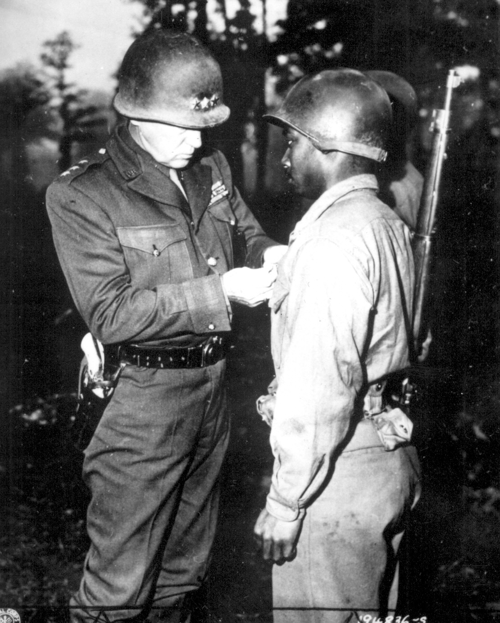 Friends of Midland
Twelfth Annual Memorial Event
Friends of Midland
Twelfth Annual Memorial Event
May 28, 2005 11:30 AM

Placing of colors United States Colored Troops

Musical Selection Ms. Loretta Rossum

Master of Ceremonies Ms. Darlene Colon
Friends of Midland

Opening Prayer Rev. Ruby N. Boose-Thames

Remarks Mayor Tom Acri
Borough of Steelton

Remarks Senator Jeffrey Piccola

Remarks Rep. Ron Buxton

Poem Ms. Krister Elliott

Remarks Mr. George Lebo

Recognition Black History Essayists

Keynote Address George F. Nagle

Remarks Ms. Linda Spotts
Harrisburg East Rotary

Acknowledgements Ms. Barbara Barksdale
& Closing remarks President, Friends of Midland

Salute of Volley United States Colored Troops

Taps United States Colored Troops

Closing Prayer Rev. Ruby N. Boose-Thames

⧫ African American troops through history

