Friends of Midland

Memorial Day Services

May 28, 2005
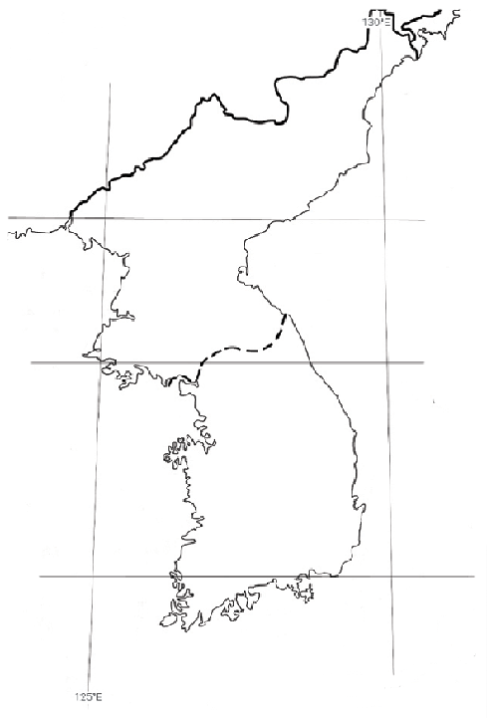

Honoring

African

American

Military

Service

in Korea

1950

to 1953



